Dedham Transcript Article
About the Mass. Memories Road Show Pilot
October 24, 2004
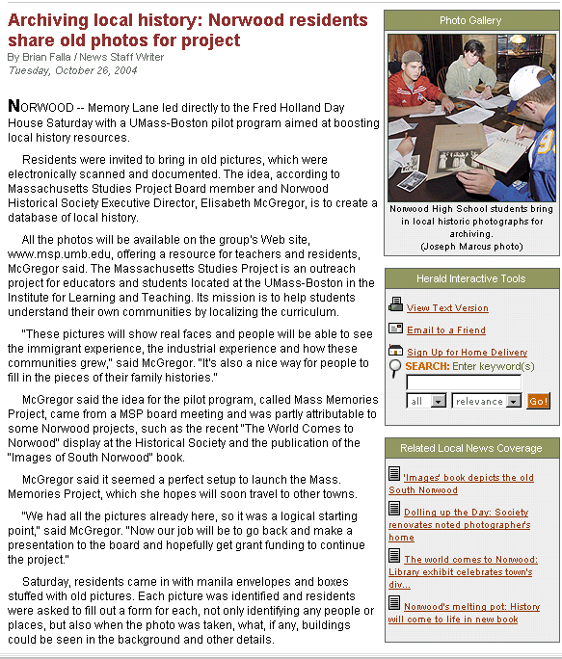

October 24, 2004

Dedham Transcript Article
About the Mass. Memories Roadshow Pilot
October 24, 2004
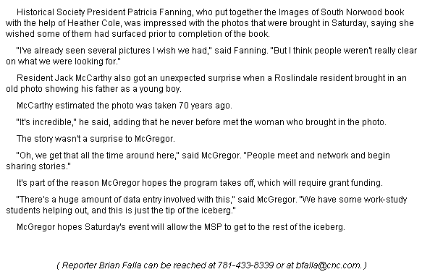
(cont'd)

